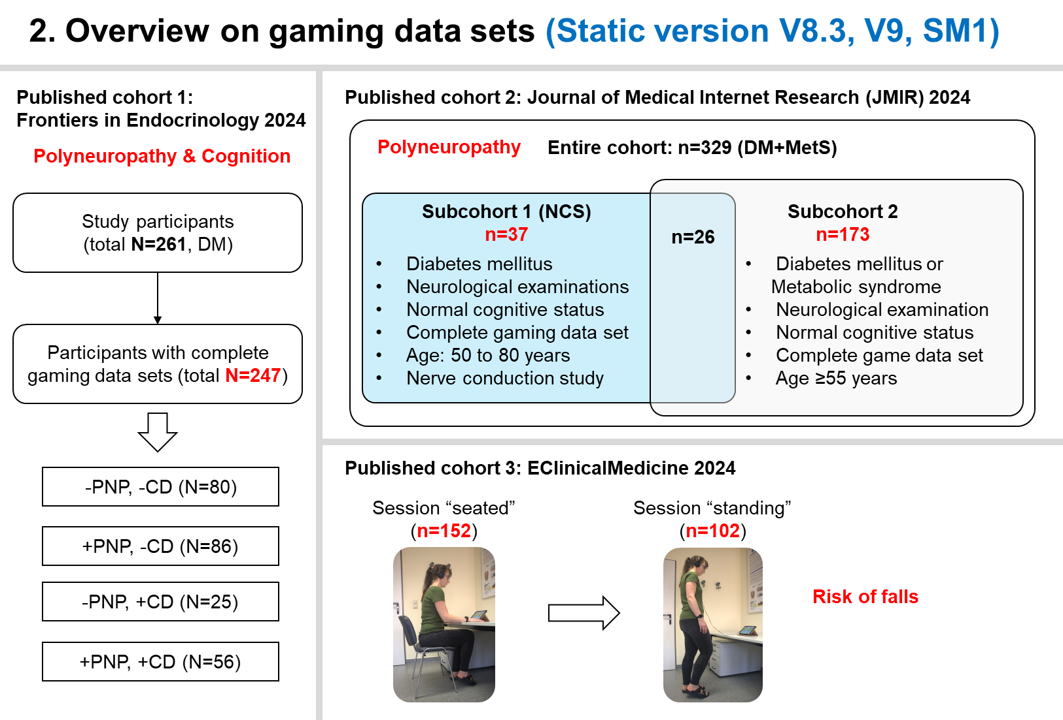

- Create peripheral neuropathy (PNP) label
  - Get NSS, NDS in number (0-10)
  - Adjust vibration sensation (sub-score of NDS) according to proband age (in years)
    - If age > 70 years, vibration sensation <4 refers to abnormal
    - Otherwise ≤ 70 years, vibration sensation <5 refers to abnormal
  - Calculate PNP label according to one of the conditions below:
    - Adjusted NDS ≥ 6 out of 10 points
    - Adjusted NDS ≥ 3 out of 10 points and NSS ≥ 5 out of 10 points
- Create cognitive impairment (CI) label
  - Basics of the MoCA score
  - Range: 0–30 points. Higher = better cognition. Wikipedia+1Domains tested: attention, executive function, memory, language, visuospatial skills, abstraction, orientation.
  - Champions for Health+1There is usually a +1 point correction if the person has ≤12 years of formal education, to reduce false positives in people with less schooling.
  - The original MoCA validation and the official MoCA site generally recommend: ScienceDirect+1
    - ≥26 / 30: often considered “normal”
    - <26 / 30: possible cognitive impairment → needs further clinical evaluation
    - MoCA 19-25 out of 30 points -> Mild Cognitive Impairment
    - MoCA 0-18 out of 30 points -> moderate–severe dementia

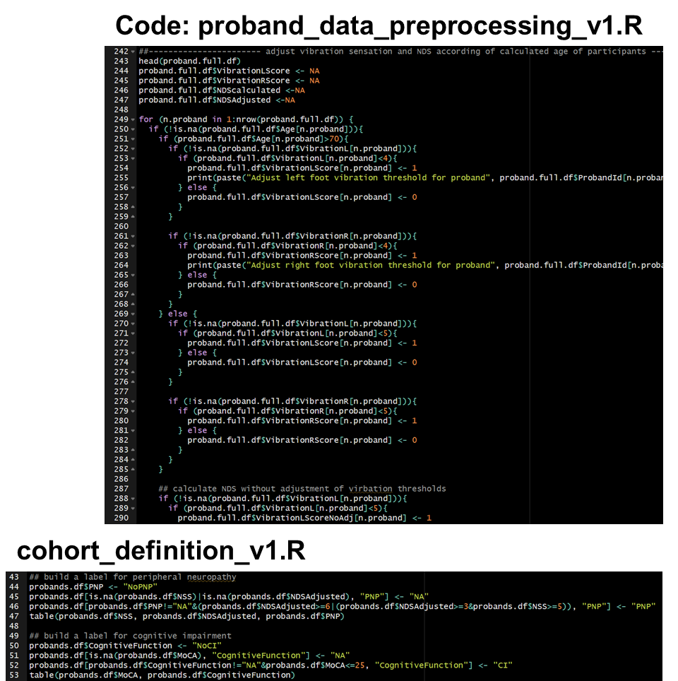

Migdalis, I.N.; Tentolouris, N.K.; Didangelos, T.P.; Papanas, N.; Bristianou, M.X.; Mavrogiannaki, A.N.; on behalf of the PRENEDIG Study. A Nationwide Study on the Prevalence of Peripheral Neuropathy in Patients with Type 2 Diabetes Mellitus in Greece—The PRENEDIG Study. J. Clin. Med. 2025, 14, 6723. https://doi.org/10.3390/jcm14196723
Sun R, Ge B, Wu S, Li H, Lin L. Optimal cut-off MoCA score for screening for mild cognitive impairment in elderly individuals in China: A systematic review and meta-analysis. Asian J Psychiatr. 2023 Sep;87:103691. doi: 10.1016/j.ajp.2023.103691. Epub 2023 Jul 14. PMID: 37499366.

